Schedule for Oak Bay Glee Club

The Oak Bay Glee Club in Savannah, Georgia provides its members with a schedule of events in three categories: Rehearsals, Workshops, and Performances. As the office manager for the glee club, you need to create the Spring schedule that covers dates in April and May. You will Create Tables, Format Tables, and Add and Modify a Graphic.

# Create Tables

You need to set up the document in landscape format so that the complete schedule is 9” wide Then you need to create a small table to contain the legend and a large table to contain the schedule.

## Steps:

1. Open a new blank document in Word, click the Page layout tab, click the Orientation button in the Page Setup group, click Landscape, click Margins in the Page Setup group, then click Custom Margins.
2. Set the Top Margin to .6 and the Bottom Margin to .4. Save the document as PR A-Oak Bay Glee Club Schedule.
3. Click Themes in the Themes group click Facet, click the View tab, click the Page Width button in the Zoom group, type Oak Bay Glee Club Spring Schedule, select the text, click the Home tab, then increase the font size to 28 pt.
4. Verify that the text is still selected, click the Bold button in the Font group, click the Text Effects button in the Font group, click Gradient Fill – Orange, Accent 4, Outline (second row, third column), then click the Align Text Right button in the Paragraph group.
5. Press [Enter] once, click the Clear Formatting button in the Font group, click the Insert tab, click the Table button in the Tables group, drag to create a table that is 2 columns wide and 3 rows high, then enter text as shown in the figure below.

|  |  |
| --- | --- |
| Rehearsal |  |
| Workshop |  |
| Performance |  |

1. Click cell 1 (contains “Rehearsal”), click the Table Tools Layout tab, click Properties in the Table group, click the Column tab, select the contents of the Preferred width text box, type 1.5, click Next Column, select the contents of the Preferred width text box for column 2, then type .6.
2. Click the Table tab in the Table Properties dialog box, click the Right button in the Alignment section, click OK, click Select in the Table group, click Select Table, click the Table Tools Design tab, click the Bottom Border list arrow in the Table Styles group, click No Border, then press 🡻 once.
   1. With the table borders removed, you can see faint lines, called gridlines, that indicate the location of rows and columns. If you cannot see gridlines after removing the table borders, click anywhere in the table, click the Table Tools Layout tab, then click View Gridlines in the Table group.
3. Press [Enter] once, click the Insert tab, click the Table button in the Tables group, click Insert Table, type 7, press [Tab], type 18, then click OK.
4. Enter the text for the first three rows as shown in the figure below, then save the document.

|  |  |  |  |  |  |  |
| --- | --- | --- | --- | --- | --- | --- |
| Monday | Tuesday | Wednesday | Thursday | Friday | Saturday | Sunday |
| April |  |  |  |  |  |  |
| 1 | 2 | 3 | 4 | 5 | 6 | 7 |

# Format Tables

In the completed schedule, some cells are merged to create larger cells, the dates are formatted in a small font size and different levels of shading indicate the different schedule categories. You need to enter text into the table and format the schedule.

## Steps:

1. Click to the left of April to select all the cells in row 2, click the Table Tools Layout tab, click Merge Cells in the Merge group to merge the seven cells into one cell, click the Home tab, click the Grow Font button in the Font group two times, click the Bold button in the Font group, the click the Center button in the Paragraph group.
2. Click the cell below 2, type Ensemble, press [Tab] four times, type Jazz Workshop for Saturday, select the two cells under 6 and 7, then merge them into one cell.
3. Refer to the figure below to enter the remaining text, merge cells where needed and use the Format Painter to match the formatting of “May” with the formatting of “April”.

|  |  |  |  |  |  |  |
| --- | --- | --- | --- | --- | --- | --- |
| Monday | Tuesday | Wednesday | Thursday | Friday | Saturday | Sunday |
| **April** | | | | | | |
| 1 | 2 | 3 | 4 | 5 | 6 | 7 |
|  | Ensemble |  |  |  | Jazz Workshop | |
| 8 | 9 | 10 | 11 | 12 | 13 | 14 |
|  |  | Ballads | Ensemble |  |  |  |
| 15 | 16 | 17 | 18 | 19 | 20 | 21 |
|  | Ensemble |  | Small Group | Spring Gala |  |  |
| 22 | 23 | 24 | 25 | 26 | 27 | 28 |
|  | Dancers Only |  |  |  | Show Tunes Workshop | |
| 29 | 30 |  |  |  |  |  |
| **May** | | | | | | |
|  |  | 1 | 2 | 3 | 4 | 5 |
|  |  | Soloists | Ensemble | Show Stoppers | Show Stoppers |  |
| 6 | 7 | 8 | 9 | 10 | 11 | 12 |
|  |  | Barbershop | Show Stoppers | Show Stoppers | Show Stoppers |  |
| 13 | 14 | 15 | 16 | 17 | 18 | 19 |
|  | Soloists |  | Ensemble | Retreat on Heron Island: Ensemble | | |

1. Click to the left of row 1 (contains the days of the week), click the Table Tools Design tab, click the Shading list arrow in the Table Styles group, click Green, Accent 1, Darker 50%, right-click the selected cells, click the Font Color list arrow on the Mini toolbar, click the White, Background 1 box, then apply bold and centering.
2. Click the cell to the right of the Rehearsal cell in the legend table, click the Shading button in the Table Styles group to fill the cell with Green, Accent 1, Darker 50%, refer to the figure below to fill the remaining legend table cells, then format the text in column 1 of the legend table with bold and right alignment.

|  |  |  |
| --- | --- | --- |
| **Rehearsal** |  | 🡸 Fill with Green, Accent 1, Darker 50% |
| **Workshop** |  | 🡸 Fill with Green, Accent 1, Lighter 40% |
| **Performance** |  | 🡸 Fill with Green, Accent 1, Lighter 80% |

1. Click to the left of the row containing the dates for the first week of April (1, 2, 3, etc.), press and hold [Ctrl], click to the left of each of the rows containing dates so that only the eight rows containing dates are selected, click the Home tab, click the Font Size list arrow, then click 9.
2. Select the row containing the two events for the first week of April (row 4), click the Table Tools Layout tab, select the contents of the Height text box in the Cell Size group, type .4, press [Enter], click in the row containing the events for the second week of April (“Ballads,” “Ensemble”), press [F4], press 🡻 two times, press [F4], then continue to use 🡻 and [F4] to set the height of only the rows containing events.
   1. The [F4] key is the repeat command on most computers. You can use the [F4] key to repeat the last command you performed, which in this case is changing the height of a table row.
3. Move the pointer over the left side of the cell containing “Ensemble” in row 4 until the point changes to 🡽, click once to select the cell, press and hold [Ctrl], select all the cells filled with Dark Green, click the Table Tools Design tab, click the Shading list arrow, click Green, Accent 1, Darker 50%, right-click any selected cell, then click the Font Color button on the mini toolbar. Refer to the figure below to fill all the cells containing workshop with Green, Accent 1, Lighter 40%, and all the cells containing performances with Green, Accent 1 Lighter 80%, then save the document.

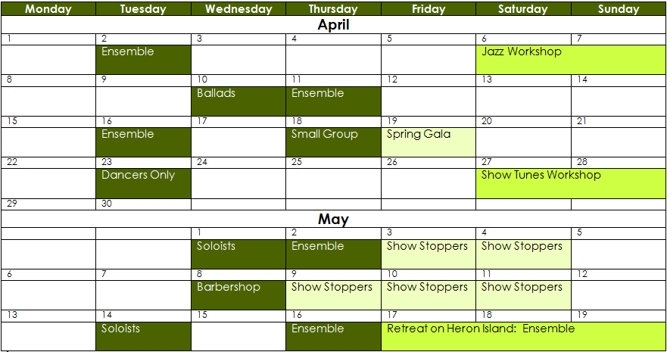

Green, Accent 1, Lighter 80%

Green, Accent 1, Lighter 40%

Green, Accent 1, Darker 50%

# Add and Modify a Graphic

You enhance the complete schedule with a clip art picture that you modify. In the original clip art, the image of the singer faces to the left and the image contain several other objects. You need to remove the objects you do not want and “flip” the image so that it faces right. Finally, you need to vertically and horizontally center all the text in the schedule and enter the address of the club at the bottom of the page.

## Steps:

1. C:\Users\jmoyer\AppData\Local\Microsoft\Windows\Temporary Internet Files\Content.IE5\E3WILO73\MC900198386[1].wmfScroll to the top of the document, click to the left of “Oak”, click the Insert tab, click the Clip Art button in the Illustrations group, select the content of the Search for text box in the Clip Art task pane, type rock star (make sure to check the “Include Office.com content” box), click Go, then click the clip art picture shown below.
2. Close the Clip Art task pane, increase the zoom to 200%, right-click the clip art picture, click Edit Picture, then click Yes.
   1. The picture is broken into its component parts. You can click and delete any object that you do not want to include in the picture.
3. Click the background object, then press [Delete].
4. Position the pointer over the upper-left corner of the picture, click and rag to select all the objects to the left of the singer, press [Delete], then select and delete all the remaining objects so that the singer appears as shown as shown below.



1. Click Select in the Editing group, click Select All, click the Drawing Tools Format tab, click the Group button in the Arrange group, then click Group.
   1. All the objects that make up the singer are grouped into one object that you can now flip so that the singer faces to the right.
2. Click the Rotate button in the Arrange group then click Flip Horizontal.
3. Click away from the picture, change the zoom to 100%, click the picture again, click just the gray frame of the picture, click the Drawing Tools Format tab, click Position in the Arrange group, select Position in Top Left with Square Text Wrapping, click the Size button in the Size group if you do not see the Height text box, change the height to 1.5”, then deselect the clip art image.
4. Click anywhere in the table, click the Table Tools Layout tab, click Select in the Table group, click Select Table, then click the Align Center button in the Alignment group.
5. Press [Ctrl][End] to move to the bottom of the document; type and format the contact information as Tahoma, 11 pt, italic, and centered as shown in the figure on the next page; save the document and place it in your Dropbox folder.

***Thank you!***