Martha’s Vineyard Beach Scene
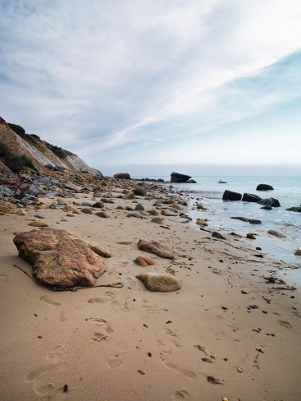This is a picture of a beach on Martha’s Vineyard after a big storm in September. The waves were crashing and the tide was going out. The red clay cliffs stood out against the gray of the beach and the ocean, and the overcast sky gave a misty softness to the scene.
Off in the distance, you can see two people walking among the large boulders jumbled on the beach. In the middle of summer, when the island’s population increases dramatically, there would be many people on the beach—sunning, swimming, walking, flying kites, and just hanging out enjoying the ocean ambience.
I like this picture because it is one of my favorite places. Most people think of bright, warm, sunny days at the beach, but I think this beach is beautiful in all types of weather. A beach on a cool, cloudy day can be an invigorating place to walk. You very often have long stretches of the beach to yourself, so you can really appreciate the natural wonders of surf, sand, rocks, and cliffs.

