Zebra
Zebra travel in large herds, and often mingle with other wildlife, such as wildebeest. The most distinguishing feature of zebra is, of course, the black and white stripes. The stripes help protect the animals by providing camouflage; when they stand close to one another, it is difficult for predators to see where one zebra begins and another ends.
We will see many zebra while we are on Safari. Herds made up of tens of thousands of zebra have been known to migrate across the Serengeti plains.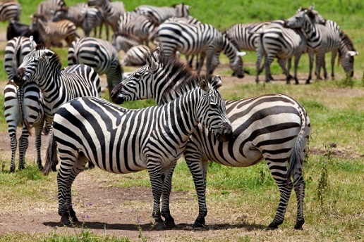
A zebra may look like a stocky pony, but it is a wild animal and will fight fiercely when it must.

