Business Cards for Pierre Lefèvre

Pierre Lefèvre works from his apartment in Los Angeles as a composer of film scores. Pierre has asked you to create a sheet of business cards for him. He wants you to combine text and graphics to make his business card eye-catching. To create Pierre’s business cards, you need to Create Labels and Enter Text, Add a WordArt Logo, and Add a Graphic.

# Create Labels and Enter Text

You use a business label sheet that you select in the labels Options dialog box as the basis for Pierre’s business cards. You enter text in one label and use the Symbol dialog box to insert the “è” in Pierre’s last name (Lefèvre). Finally, you format the text on the business card to emphasize Pierre’s name and position.

## Steps:

1. Start Word, click the Mailings tab, then click Labels in the Create group.
   1. On the Labels tab of the Envelops and Labels dialog box, you can select the size and type of label you need to create a sheet of business cards.
2. Click Options, click the Label vendors list arrow, then scroll to and click Avery US Letter.
3. Scroll down the Product number list box, click 5371 Business Cards, click Details, verify that the Label height is 2” and the Label width is 3.5”, click OK, the click OK.
4. Verify that the Full page of the same label option button is selected in the Print section, then click New Document.
5. Change the zoom to 130%, then type Pierre Lef in the upper-left table cell.
6. Click the Insert tab, click Symbol in the Symbols group, click More Symbols, select (normal text) as the Font type if necessary, select the contents of the Character code box, type 00E8 to select the è, click Insert, then click Close.
7. Type vre so the full name is Pierre Lefèvre, save the document as PR A-Business Cards for Pierre Lefevre, then type the remaining text for the business card as shown below.

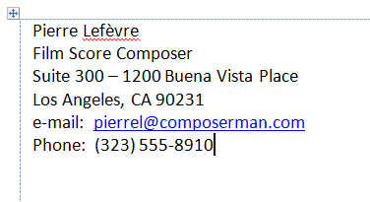

1. Click the first line of text, click the Page Layout tab, select the contents of the Before text box in the Spacing area of the Paragraph group, type 36, press [Enter], select the six lines of text, click the Home tab, click the Align Text Right button in the Paragraph group, enhance Pierre Lefèvre with Bold and a font size of 14 point, change the font size of the remaining text to 10 point, then enhance Film Score Composer with Italic.
2. 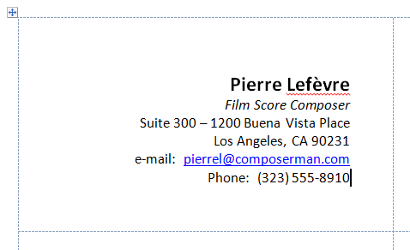Select all six lines of text, click the Page Layout tab, select the contents of the Right text box in the Indent section of the Paragraph group, type 0.4, press [Enter], deselect the text, then save the document. Your business card should now look like the sample below.

# Add a WordArt Logo

You need to add a WordArt Object to the business card and then modify it.

## Steps:

1. Click to the left of “Pierre”, click the Insert tab, then click the WordArt button in the Text group.
2. Click Gradient Fill – Purple, Accent 4, Reflection (fourth row, fifth column). *If you do not see this option simply use a gradient fill – purple accent. You may need to click on the design tab and change the color scheme of the document.*
3. Type PL, select PL, click the Home tab, click the Font list arrow, type MV, then select the MV Boli font.
4. Click the Line and Paragraph Spacing button in the Paragraph group, then click Remove Space Before Paragraph.
   1. The WordArt object now fits neatly in the upper-left corner of the table cell.
5. Click the Drawing Tools Format Tab, click the Text Effects button in the WordArt Styles group, point to Reflection, then click No Reflection.
   1. You can modify a WordArt object in many ways by selecting different options from the list of enhancements that appear when you click the Text Effects button in the WordArt Styles group. You can add a shadow, a reflection, a glow, or a bevel, apply a 3-D rotation effect, and use the Transform option to change the shape of the WordArt object.
6. Click the Text Effects button again, point to Shadow, click Offset Diagonal Bottom Left (top row, third column in the Outer section), click the Text Effects button once more, point to Bevel, then click Cool Slant (first row, fourth column in the Bevel section.
7. Click the Rotate button in the Arrange group, click More Rotation Options, select the contents of the Rotation text box, type 340, then click OK.
8. 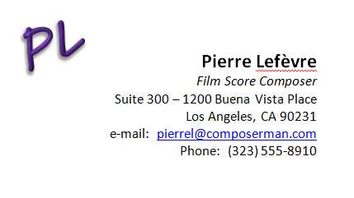Click away from the WordArt object save the document, then compare the business card to the figure below.

# Add a Graphic

You need to add a clip art picture and then modify it so that only part of the picture remains, and then you need to change the theme applied to the document so that different fonts and fill colors are used.

## Steps:

1. Click to the left of “Pierre”, click the Insert tab, click ClipArt or Online Pictures in the Illustrations group delete the contents in the Search for text box in the task pane, type musical notes border, click , then click the clip art picture that includes a keyboard image as shown below. ***You are looking for the keyboard section NOT the musical notes.***

C:\Users\jmoyer\AppData\Local\Microsoft\Windows\Temporary Internet Files\Content.IE5\S1YKZD9M\MC900054657[1].wmf

Find the keyboard in your clipart selection.

1. Close the ClipArt task pane, click the Crop button in the Size group, click Crop if the Crop command is not active, drag the lower-middle crop handle up to select on the keyboard at the top.
2. Click away from the image to deselect it, click the image again, click the Picture Tools Format tab, click the Wrap Text button in the Arrange group, then click Square.
3. Click the launcher in the Size group, click the Lock aspect ratio check box to deselect it, enter .25 in the Height Absolute text box, enter 2.8 in the Width Absolute text box, then click OK.
4. Drag the keyboard image to the bottom of the business card, then release the mouse button so the keyboard image appears centered at the bottom.
5. Click anywhere in the text of the business card, click the Table Tools Layout tab, click Select in the Table group, click Select Cell, click the Home tab, click the Copy button in the Clipboard group, click in the upper-right table cell, then click the Paste button in the Clipboard group,
6. Click away from the table cell to deselect it, click the Design tab, click Themes in the Themes group, move the pointer over each of the themes to view how the fill color of the WordArt object and the font applied to text changes, then click Metropolitan.
7. Click the View tab, click One Page in the Zoom group, click the Home tab, then click each blank table cell and use the Paste button to paste the contents of the business card in each of the remaining table cells.
8. Select the telephone number in the lower-right card, type your name, save the document and place it in your Dropbox.

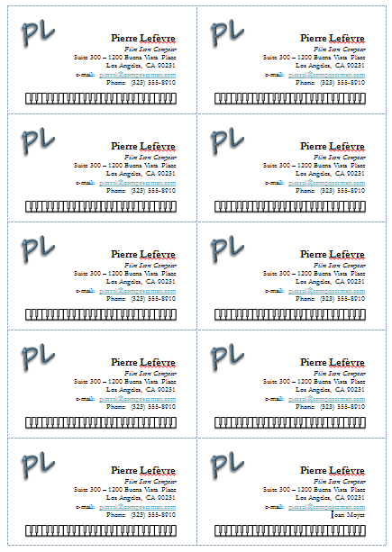

# (we will not be completing this portion of the assignment) * If you finish early and would like to try making your own business cards you are free to do so, but make sure ALL of your other work is complete first! Independent Challenge:

Use a business card label product, such as the Avery 5371 label, to create a sheet of business cards for yourself. Follow the directions to create your business cards.

1. Open a new blank document, open the Envelopes and Labels dialog box from the Mailings tab, select one of the Business Card products from the list of available label products in the Label Options dialog box, click OK, verify that the labels will print on a full sheet, then click New Document.
2. Enter your name and address on the business card, then save the business card as PR A-My Business Cards.
3. Apply formatting to selected text. For example, you may want your name to appear in ta larger font and in bold.
4. Create an attractive WordArt logo based on your initials. Experiment with some of the many text effects available for formatting a WordArt object. For example, you can modify the shading and line color, add or remove a shadow, or add a 3-D effect.
5. Reduce the size of the logo, modify the Before Paragraph spacing, and position the logo attractively on the business card.
6. Insert a clip art picture that you modify in some way or draw a shape such as a triangle or circle.. You can crop the clip art picture, and you can fill the shape with a fill color and modify the border style and color. Experiment until you are pleased that the graphic you include on your business card effectively communicates the image you want to project.
7. Modify the theme applied to the business cards.
8. Copy the contents of the upper-left cell to every cell in the table so that you have a full sheet of business cards.
9. Save the document and place it in your Dropbox.