Travel Expense Report for Bright Lights Learning
The three sales representatives at Bright Lights Learning have each submitted their travel expenses for May. You need to record these expenses and prepare an expense report. For this project, you Create the Expenses Form, Calculate Expenses, and Prepare the Expense Report.

Create the Expenses Form
You need to create a form to record expenses in Sheet1 of a new workbook and then copy the form to Sheet2 and Sheet3.

  - Steps:
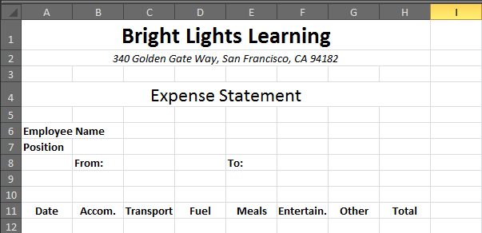
- Open a new workbook in Excel, apply the Perspective theme, enter and format the labels as shown in the figure below then save the workbook as PR C-Expanse Statements for Bright Lights Learning.
Italic, merged and centered across cells A2:H2
Bold, 22 pt, merged and centered across cells A1:H1
Bold all labels

- Fill cell A1 with Dark Purple, Accent 4, Lighter 60%, click cell A30, type Current mileage, press [Tab], type $.35, then press [Enter].
  - Note: When you enter expenses in the expense form, you will use the value in cell B30 in calculations for mileage. You use cell addresses in formulas rather than typing values in order to minimize errors and provide flexibility.
- Click cell H12, click the Formulas tab, click the AutoSum button in the Function Library group, select cells B12:G12, press [Enter], copy the formula to cell H25, click cell B26, click the AutoSum button select cells B12:B25, press [Enter], then copy the formula to cell H26.
  - Note: Zeroes appear in the cells that contain formulas.

- Type the text for cells G27:G29, as shown in the figure below, click cell H27, enter the formula =SUM(H12:H25), press [Enter], click cell H29, enter the formula =H27-H28, press [Enter], select cells B12:H29, click the Home tab, then click the Accounting Number Format button in the Number group.
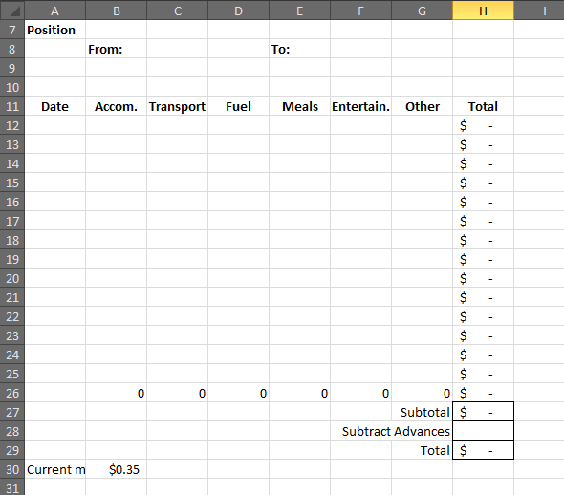
Apply borders to cells H27, H28, & H29
Border and right-align cells G27, G28, & G29

- Select rows 6, 7, and 8, click the Format button in the Cells group, click Row Height, type 25, click OK, select columns B through H, click the Format button in the Cells group, lick Column Width, type 12, click OK, then increase the width of column A to 18.
- Select cells B6:G6, click the Bottom Border list arrow in the Font group, lick Bottom Border, then add a bottom border to cells B7:G7, cells C8:D8, and cells F8:G8.
- Select cells A11:H26, click the Bottom Border list arrow, click All Borders, then format text and add borders to cells G27:H29.
- Double-click the Sheet1 tab, type Wong, press [Enter], name the Sheet2 tab Martin, name the Sheet3 tab Goldberg, go to the Wong sheet, select the entire worksheet, click the Copy Button, show the Martin worksheet, then click the Paste button.

- Show the Goldberg worksheet, click the Paste button, click cell A1, reduce the zoom to 80%, compare the worksheet to the figure below, then save the workbook.
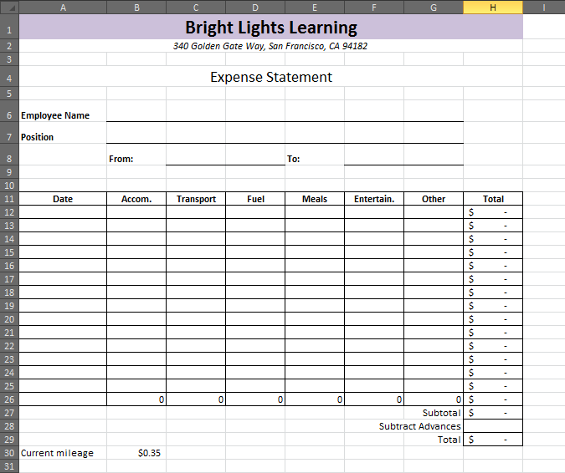

Calculate Expenses
The three sales representatives have provided you with receipts from the various business trips they took in May. You need to enter these expenses in the expense form.

  - Steps:
- Click the Wong sheet tab, click cell B6, type Abigail Wong, press [Enter], then type Sales Representative.
- Click cell C8, type May 15, 2013, press [Tab] three times, type May 18, 2013, then press [Enter].
  - Note: When you enter the dates, Excel automatically changes the format to 15-May-13.
- Click cell C8, press and hold [Ctrl], click cell F8, click the Number Format list arrow in the Number group, click More Number Formats, click Date in the Category list select the date format that corresponds to March 14, 2001 in the Type list (you’ll need to scroll down), then click OK.
- Click cell A12, type May 15, 2013, press [Tab], type =420/3, press [Tab], type =190*1.09, press [Tab], type =12*, click cell B30, press [Tab], type =14+45, then press [Enter]
  - Note: You’ve entered the expenses that Abigail incurred on May 15. She stayed one of the three nights in Denver ($420/3), she flew to Denver ($190 + 9% tax), she drove 12 miles to the airport (12*B30), and she bought lunch and dinner ($14 + $45). The total in cell H12 should be $410.30.
- Enter the remaining expenses for Abigail Wong According to the following information:
  - On May 16 and 17, Abigail stayed two more nights at the Denver Hilton Hotel at the same rate she paid on May 15. From May 16 to 17, she rented a car @ $42.50/day + $14.30/day for insurance. On May 16, she drove 25 miles; she spent $10 on breakfast, $25 on lunch, and $50 on dinner; in the evening she spent $72 on a theater ticket. On May 17, she drove 35 miles, she spent $105 on meals, and she spent $12 on other expenses. On May 18, she paid $15 for breakfast, she drove 15 miles from the airport back home, and she spent $13 on other expenses.
- Verify that the total in cell H29 is $1,132.15
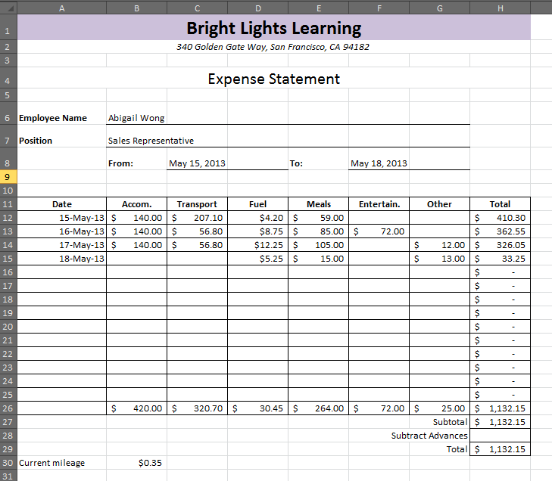

- Click the Martin sheet tab, then enter the information and expenses below for Harry Martin.
  - Harry Martin, Sales Representative, incurred his expenses from May 8 to May 16, 2013, and has already been advanced $150. On May 8, Harry drove 40 miles, flew to Seattle for $120 + 9% tax, stayed overnight at the Pikes Place Inn for $150 + 7% tax, and spent $60 on meals. On May 9, he took a ferry ride for $50, drove 40 miles, and spent $45 on meals and $25 on other expenses. On May 15, he drove 40 miles, flew to Los Angeles for $110 + 9% tax, stayed overnight at the Pacific Heights Motel for $110 + 9% tax, and spent $75 on meals. On May 16, he drove 40 miles and spent $35 on meals and $20 on other expenses.
- Verify that Martin’s total expenses (less his advance) are $747.10 in cell H29.
- Click on the Goldberg tab, then enter the information and expenses below for Rachel Goldberg, verify that Rachel’s total expenses (less her advance) are $950.45 in cell H29, then save the workbook.
  - Rachel Goldberg, Sales Representative, incurred her expenses from May 5 to May 11, 2013, and has already been advanced $200. On May 5, Rachel drove 27 miles and spent $40 on meals. On May 9, Rachel flew to Chicago for $275 + 9% tax, spent $70 on meals, and drove 18 miles. On May 9 and 10, she stayed at the Lakeside Hotel for $225/night + 11% tax. On May 10, she spent $90 on meals, $50 on entertainment, and $43 on other expenses. On May 11, she drove 27 miles and spent $33 on meals.

Prepare the Expense Report
You need to consolidate data from the Wong, Marin, and Goldberg worksheets to create the May expense report. Then, you need to enhance the report attractively. The final Reimbursement Total should be $2,529.70.

  - Steps
- Click the Insert list arrow in the Cells group, click Insert Sheet, double-click the Sheet4 tab type Report, press [Enter], right-click the Report tab, click Move or Copy, click (move to the end), then click OK.
- Click the Wong sheet tab, copy cells A1:A4, click the Report tab, click the Paste button in the Clipboard group, click cell A4, then change “Expense Statement” to May Expense Report.
- Enter and format the labels as shown below.
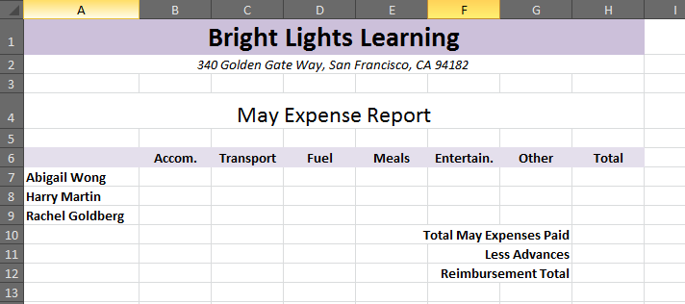
Labels in cells A6:H6 are bold, centered, and filled with Purple, Accent 4, Lighter 80%; the width of columns B to H is set at 10
Labels in cells G10:G13 are bold and right-aligned
Labels in cells A7:A9 are bold; the width of column A is adjusted to fit the names

- Click cell B7, type =, click the Wong sheet tab, click cell B26, press [Enter], click cell B7, copy the formula through cell G7, click cell B8, type =, click the Martin sheet tab, click cell B26, press [Enter], copy the formula though cell G8, then repeat the process to enter the amounts for Rachel Goldberg in cells B9:G9.
- Select cells B7:H9, click the Sum button in the Editing group, click cell H10, double-click , click cell H11, type =, click the Wong sheet tab, click cell H28, click in the formula bar, type +, click the Martin sheet tab, click cell H28, type +, click the Goldberg sheet tab, click cell H28, the press [Enter].
- Click cell H12, calculate Reimbursement Total, verify that the Reimbursement Total is $2,829.70, click the Wong sheet tab, enter an advance of $300, then verify that the Reimbursement Total in the Report tab is now $2,529.70.
- Select cells H7:H9, click Conditional Formatting in the Styles group, point to Icon Sets, then select the 3 Traffic Lights (Unrimmed) icon set (1st row, 1st column in the Shapes section).
- Click Conditional Formatting, point to Icon Sets, click More Rules, click Reverse Icon Order, click the top Type list arrow, click Number, type 1000 in the Value text box, press [Tab], complete the New Formatting Rule dialog box as shown below, click OK, then widen column H as needed to fit content.
  - Note: The conditional formatting rules highlight which sales representatives have spent the most money on expenses.
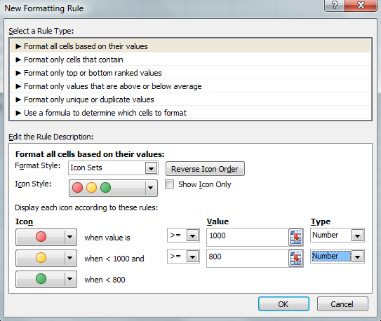

- Select rows 6 through 12, click Format in the Cells group, click Row Height, type 20, click OK, click the Page Layout tab, click Margins, click Custom Margins, set the top margin at 1.5, set the left and right margins at 0.45, then click OK.
- Click the File tab, click Print, click Page Setup, click the Fit to Option button, click the Margins tab, center the worksheet horizontally click the Header/Footer tab and include the custom header with your name in the upper right corner.

