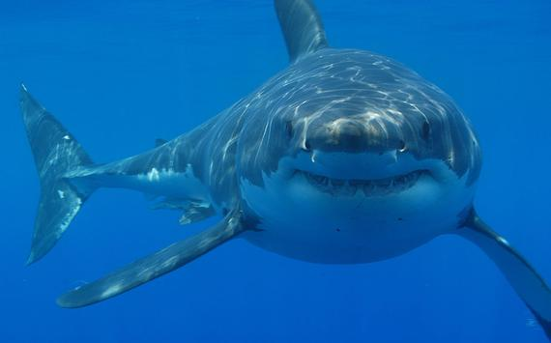
Shark Tank Worksheet
Season:
Episode:
Company Name:

Starting Valuation:
Offer(s) Valuation:

What does the product sell for? $___________
-
What is the cost to make it? $___________
=
Profit Margin $___________

Business Plan Details:

What are they planning on doing with the money the sharks give them? (i.e. Marketing, hiring, inventory, capacity planning, business analytics)

How will the Sharks get their money back? How long will it take? Explain your answer with numbers.

Track the Shark Tank Season
- Map each investor’s investing style/patterns through an entire season. How many total dollars has each invested in total? Are their patterns to what each investor likes to buy?

Company Names | Robert Herjavec  Dollars Invested | Kevin O’Leary  Dollars Invested | Barbara Corcoran  Dollars Invested | Mark  Cuban  Dollars Invested | Lori  Greiner  Dollars Invested | Daymon James  Dollars Invested

- Summarize for each person what they don’t buy and their reasoning.

Robert

Kevin

Barbara

Mark

Lori

Daymon

