Projected Budget for Camp Orca

Each year, teens, from all over North America come to Camp Orca near Anacortes in Washington State to enjoy kayaking, sailing, and camping. As the assistant to the director of the camp, you need to create Camp Orca’s budget for the 2012 summer season and then ask a series of what-if questions to determine realistic goals. For this project, you Enter and Enhance Labels, Calculate Totals, Ask What-If Questions, and Format and Print the Budget.

Enter and Enhance Labels
You need to enter and enhance the name and address of the organization, the worksheet title, the current date, and the first series of labels.

  - Steps:
- Start Excel to open a new blank workbook, click the Select All button to the left of the “A” at the upper-left corner of the worksheet frame to select the entire worksheet, click the Font Size list arrow in the Font group, then click 12.
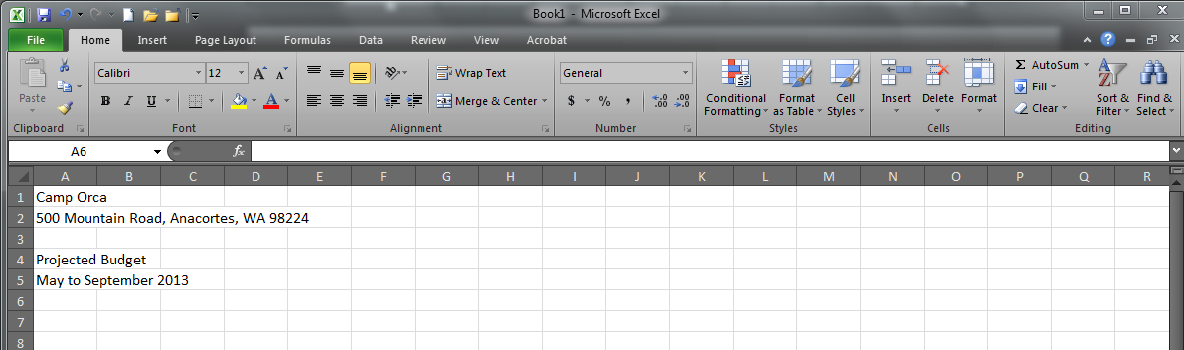
- Click cell A1, type Camp Orca, press [Enter], type the remaining labels as shown below, then save the workbook as PR C-Projected Budget for Camp Orca.
Select All
Button

- Click cell A1, click the Page layout tab, click Themes in the Themes group, click Austin, click the Home tab, click the Font Size list arrow in the Font group, change the font size to 20, then click the Bold button in the Font group.
- Select cells A4 and A5, then change the font size to 16.
- Select cells A1:G5, right-click the selection, click Format Cells, click the Alignment tab, click the Horizontal list arrow, click Center Across Selection, then click OK.
- Select cells A4:G5, click the Fill Color list arrow in the Font group, click Green, Accent 1, Darker 25%, click the Font Color list arrow in the Font group, click White, Background 1, then click the Bold button.
- Click cell B7, type May, position the pointer over the lower-right corner to show the Fill Handle pointer +, drag + to cell F7, click the Center button in the Alignment group, click cell G7, then type Totals and center it. (The five months from May to September are added and centered.)
- Point to B on the worksheet frame, click and drag to select columns B through G, click Format in the Cells group, click Column Width, type 14, then click OK.
- Click cell A8, enter labels required for cells A8:A23 as shown below, click the Review tab, click the Spelling button in the Proofing group, correct any spelling errors, then save the workbook.
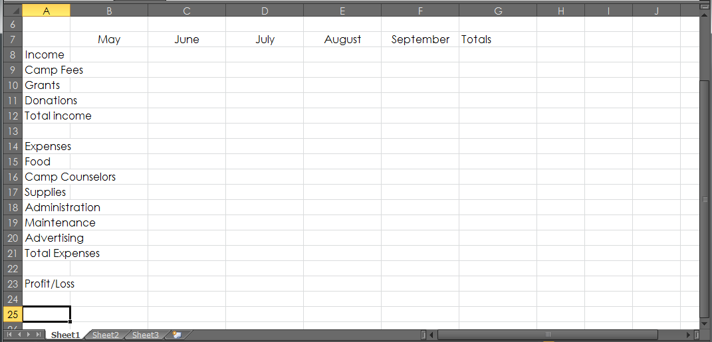

Calculate Totals
You need to enter the income and expanses that Camp Orca anticipates in 2013. Then, you need to calculate the camp fees and the total income and expenses.
  - Steps
- Double-click the column divider between columns A and B on the worksheet frame to increase the width of column A to fit all the labels.
- Click cell B10, enter the values for May as shown below, select cells B10:B20, position the pointer over the lower-right corner of cell B20, then drag + to cell F20.
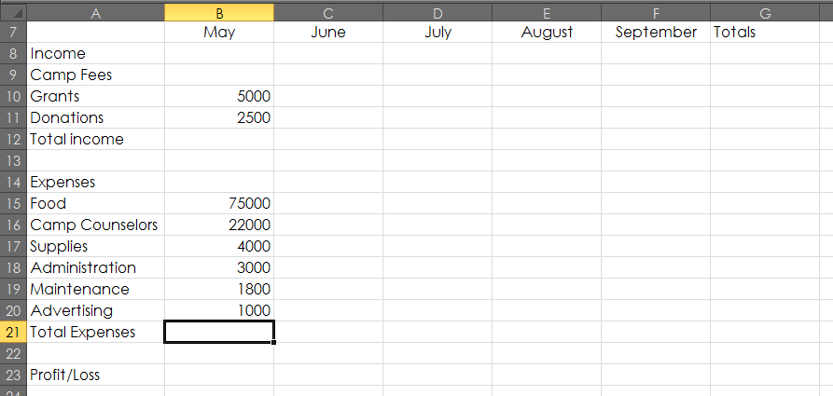
- Double-click the Sheet1 tab at the bottom of the worksheet, type Budget, press [Enter], double-click the Sheet 2 tab, type Fees, then press [Enter].
  - In the previous year (2012), you know that approximately 200 teens attended camp each month in three payment categories: one-week, two-week, and three-week. You use this data as the basis for your calculations for the 2013 budget.
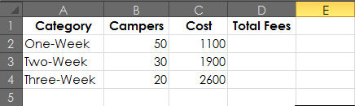
- Enter and format the labels and values in the Fees worksheet as shown below. Double-click or drag the column divider to widen column A so that the labels are clearly visible and then center and bold the labels in cells A1:D1.

- Click cell D2, type the formula =B2*C2, then press [Enter]. (D2=55000)
- Click cell D2 again, drag + down to cell D4 to copy the formula into the next two cells, click cell D5, then double-click the Sum button in the Editing Group.
- Click the Budget sheet tab, click cell B9, type =, click the Fees sheet tab, lick cell D5, press [Enter], click cell B9 again, then drag the pointer across to cell F9 to copy the formula to the other months.
- Click cell B9, select D5 in the formula bar, press [F4] to insert dollar ($) signs to make D5 an absolute reference, press [Enter], click cell B9 again, then drag + to fill cells C9:F9 with the new formula.
- Select cells B9:G12, click , select cells B15:G21, click again, click cell G22, then save the workbook.
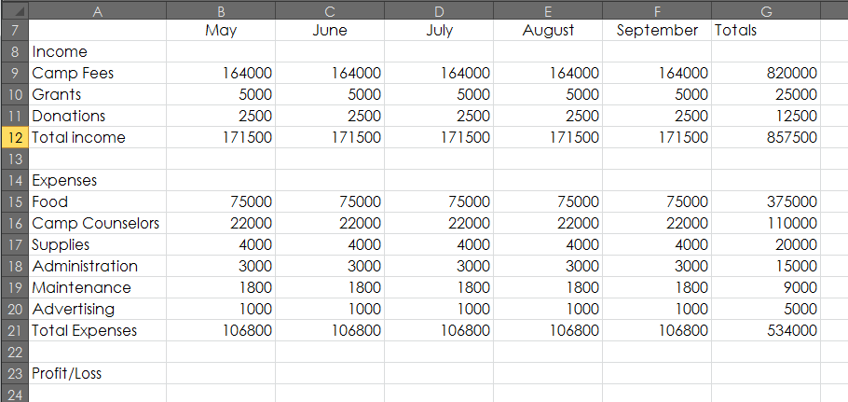

Ask What-If Questions
You need to calculate the profit you expect to make in each of the five months of the 2013 season, and then perform the calculations required to answer several what-if questions. You also create a sparkline to give you a quick visual review of the profit earned by the camp over the five months.

  - Steps
- Click cell B23, enter the formula =B12-B21, press [Enter], copy the formula across to cell G23, then click cell G23 to deselect the range.
  - The total projected profit for the 2013 camp season is 323500. The first what-if question is: “What if you raise the one-week course to $1,200?”
- Click the Fees sheet tab, click cell C2, type 1200, press [Enter], then click the Budget sheet tab.
  - By changing the value in C2, you answer the what-if question and see that your total profit in cell G23 increases to 348500. Next, you want to know, “What if an increase in the one-week camp fee results in a 30% drop in the number of campers you can expect in 2013?”
- Click the Fees sheet tab, click cell B2, replace “50” with the formula =50-(50*.3), press [Enter] then click the Budget tab to see what effect this has on the profit.
- Return to the Fees sheet, change the cost of the one-week camp fee in cell C2 to 1100 and the number of campers in cell B2 to 50, then return to the Budget sheet.
  - The value in cell G23 is again 323500. Next, you want to know, “What if you launch an $8,000 advertising campaign in May?”
- Click cell B20 in the Budget sheet, type 8000, then press [Enter].
  - Next, you want to know, “What if the May advertising campaign leads to a 30% increase in revenue from camp fees in August and September?” You edit the formula in cells E9 and F9 to reflect a potential increase.
- Click cell E9, click at the end of the formula in the formula bar, type *1.3, press [Enter], then copy the formula to cell F9.
  - The new total profit shown in cell G23 is 414900, a significant increase. As a result of this what-if analysis, you decide to keep the advertising campaign in place. Finally, you want to know, “What if you hire a full-time executive assistant for $22,000?” You divide this amount by 5 to determine the monthly rate for the five months the camp is open and then you add the total to the values entered in the Administration row.
- Click cell B18, enter the formula =(22000/5)+3000, press [Enter], then copy the formula across to cell F18.
- Click cell A25, type Growth, press [Tab], click the Insert tab, click Line in the Sparklines group, type B23:F23, then click OK.
- Click the Zoom Out button in the lower-right corner of the worksheet window until 80% appears, compare your worksheet to the one below, then save the workbook.
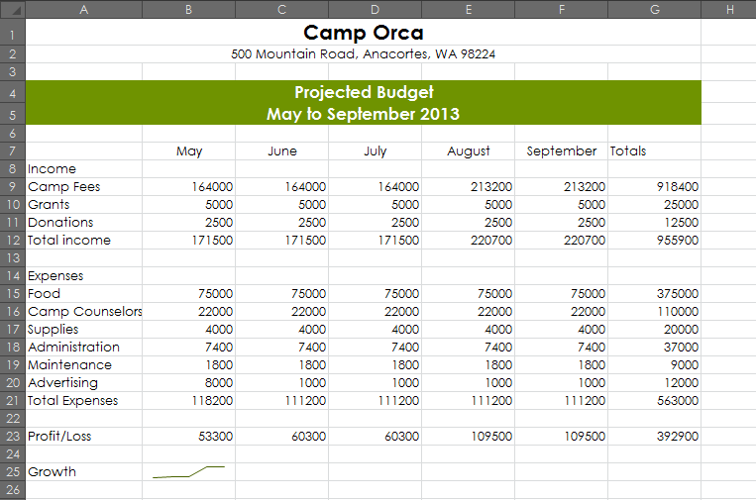

Format and Print the Budget
To make the worksheet easier to read, you need to format values using either the Accounting Number Format or the Comma Style (depending on their location in the worksheet), add border lines to selected cells, and use a variety of Page Setup features. Then you need to print a copy of your budget.
Steps
- Click the Home tab, select cells B9:G9, click the Accounting Number Format button in the Numbers group, then click the Decrease Decimal button in the Number group two times.
- Select cells B12:G12, press and hold [Ctrl], select cells B15:G15, cells B21:G21, and cells B23:G23, click , click twice, then click cell A25 to deselect the cells.
  - You use the [Ctrl] key to select a series of nonadjacent cells.
- Use [Ctrl] to select cells B10:G11 and cells B16:G20, click the Comma Style button in the Number group, click twice, then click cell A25 to deselect the cells.
- Select cells B12:G12, click the Bottom Border list arrow in the Font group, select the Top and Double Bottom Border style, then click outside the selected cells to see the change.
- Add the Top and Double Bottom Border style to cells B21:G21, then add the Bottom Double Border style to cells B23:G23.
- Select cells B7:G7 click the Bold button in the Font group, click cell A8, press and hold [Ctrl], select cells A12, A14, A21, A23:G23, and A25, then click the Bold button to format all the cells at once.
- Click cell A1, click the File tab, click Print, click Portrait Orientation, then click Landscape Orientation.
- Click the Page Setup link at the bottom of the Print page, click the Margins tab, click the Horizontally and Vertically check boxes to select them, click the Header/Footer tab, click Custom Header, type Camp Orca Budget in the left section, press [Tab] twice, type your name in the right section, click OK, then click OK again.
- Click the Print button.
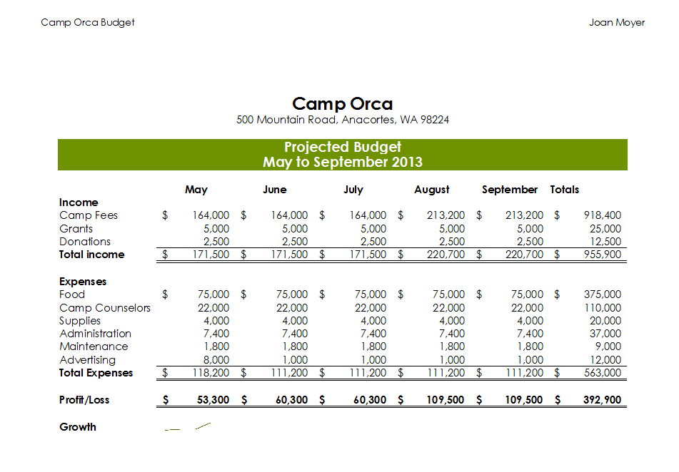
- Click Save.
- Turn in your assignment.

