Planning Budget for a European Vacation
You have a budget of $5,000 for a three-week trip to Europe with a friend. Before you buy your plane ticket, you need to determine how much you can spend on airfare, accommodation, food, entertainment, and transportation. You want to stay in first-class hotels, but your $5,000 budget may not extend that far. What kind of trip can you really afford? For this project you need to Set Up the Budget and the Calculate Options.

Set Up the Budget
  - Steps:
- Create a blank workbook in Excel, apply the Pushpin theme, type Budget, press [Enter], click cell A1, click the Home tab, click Cell Styles in the Styles group, click Accent 2 then apply bold and increase the font size to 20 pt.
- Enter and format the labels, and values shown in the figure below, adjust column widths as needed to fit the content, then save the workbook as
PR C-European Trip Budget.
Merge cells and center text across A1:E1
Merge cells & center text across A2:E2, then apply the Heading 1 style
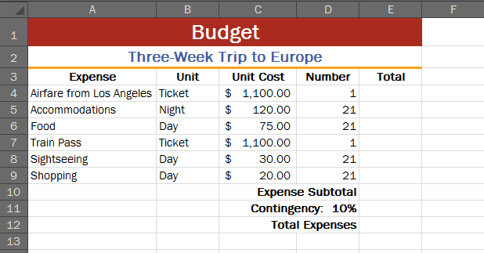

Bold & center labels in row 3

Apply Accounting Number Format to values in column C

Bold and
right-align labels in cells D10:D12

- Select cells B3:E3, click the Orientation button in the Alignment group, then click Rotate Text Up.
- Click cell E4, enter the formula =C4*D4, press [Enter], then copy the formula through cell E9.
- Click cell E10, then double-click the Sum button in the Editing group to calculate the subtotal.
- Click cell E11, calculate a 10% contingency on the subtotal, then press [Enter].
- Enter a formula in cell E12 to add the subtotal to the contingency to determine your total expenses.
  - Note: Your total expenses in cell E12 are $8,079.50. You are $3,079.50 over your budget of $5,000.
- Change the font size to 14 pt for cells A3:E12, then adjust column widths so that all data is visible.
- Save the workbook.

Calculate Options
You need to reduce the trip cost to $5,000. You decide to perform a variety of calculations to answer several what-if questions. As you enter data to answer the what-if questions in Steps 2 through 7, check the value in the Total Expenses cell against the total expenses value provided in the text. You will need to think carefully about the calculations required. For some steps, you need to insert new rows.
  - Steps:
- Rename the Sheet 1 tab Budget 1 and rename the Sheet 2 tab Budget 2, return to the Budget 1 sheet, click the Select All button in the upper-left corner of the worksheet frame, click the Copy button in the Clipboard group, click the Budget 2 tab, then click the Paste button in the Clipboard group.
- Perform the calculations required to answer the question “What if you reduce your sightseeing allowance to $20 a day?” (Total expenses are now $7,848.50)
- What if you do not buy a train pass but instead lease a car for two weeks at a cost of $800 per week and share the cost for the car lease with your friend? (Total expenses are now $$7,518.50)
- What if you stay at youth hostels for 10 days ($30/night for one), stay in small pensions for 8 days ($80.00 night for one), then stay in moderately priced hotels for the remaining 3 days ($200/night for two)?
  - You will need to insert two new rows for the various accommodation options (see the figure below). Also, do not forget to copy the formula required to calculate the expenses for each row. The total expenses are now $6,110.50.

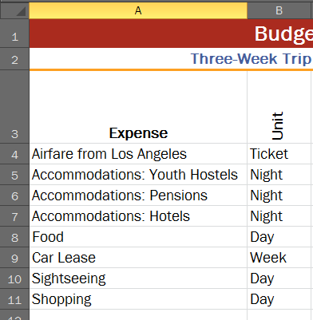

- What if you buy and cook your own food on the days that you stay in youth hostels, thereby reducing your food costs on those days to $20 a day? (Total expenses are now $5,505.50)
- If you lease a car, you will split gas costs with your friend during the two weeks that you have the car. You plan to drive approximately 1,200 kilometers; the car you plan to rent gets 15 kilometers to the liter; gas costs approximately $1.50 a liter.
  - Insert a row for gas. Remember that you are splitting the cost with your friend. The total expenses are now $5,571.50.
- What if you book a charter flight that costs $250 less than the current airfare and you further reduce your shopping allocations to $10/day?
  - Total expenses are now $5,065.50. You are still $65.05 over your budget of $5,000. You decide that you can just afford to pay the shortfall, but realize that you will need to stick very carefully to your budget.
- Add borders as shown in the figure below.

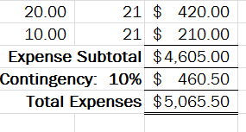

- Insert a header with your name on it. Save your file and email a copy of your spreadsheet.

