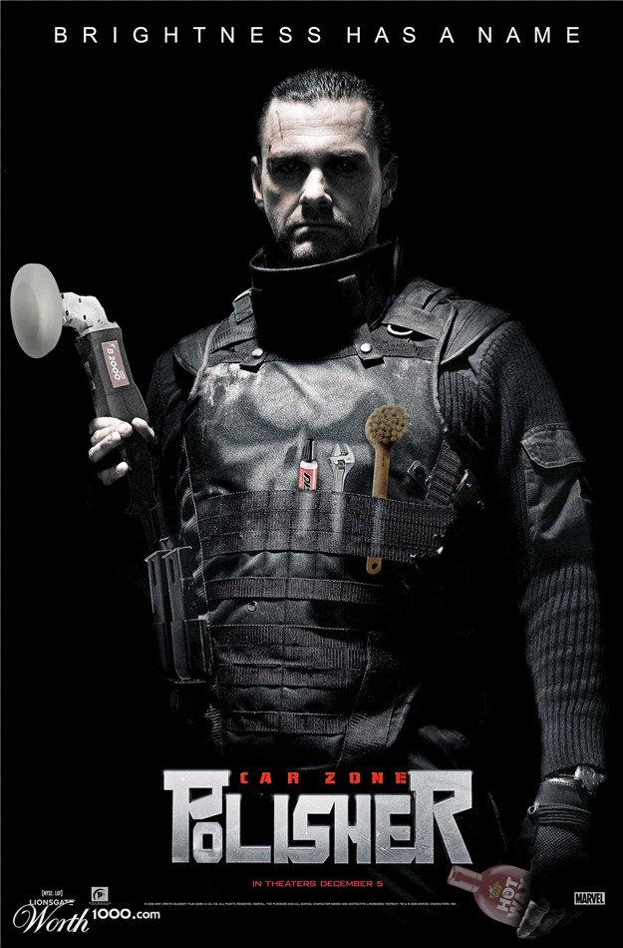

Movie Madness
Parodies of movies
All right, I'll toss a bone to you humor-oriented folk. In this contest you're going to take any image from a movie (or advertisement for it) and make a parody out of it (i.e. Lady and the Trampoline, Willie Wonka and the Lye Factory, or Fatman Begins).
The rules of this game are thus:
Take any image from a movie (or an ad or box cover) and make a parody out of it. The sillier the better! However….you must create an original idea! You can Google ideas, but you must come up with your own concept. Using Photoshop, manipulate the idea to incorporate as many items to clearly show your concept as you can think of. Be sure to use your 10 skills document to help you complete this assignment. Also, reference your textbook, it has a lot of great resources and answers to your questions. Be creative and have fun!

