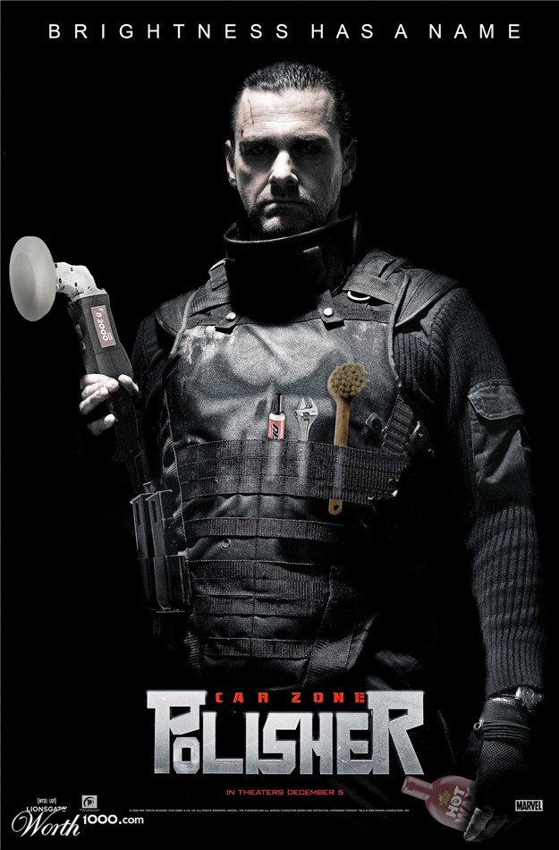

Movie Madness 9
Parodies of movies
All right, I'll toss a bone to you humor-oriented folk. In this contest you're going to take any image from a movie (or advertisement for it) and make a parody out of it (i.e. Lady and the Trampoline, Willie Wonka and the Lye Factory, or Fatman Begins).
The rules of this game are thus:
Take any image from a movie (or an ad or box cover) and make a parody out of it. The sillier the better!

