Kevin O'Leary Keynote at Notre Dame 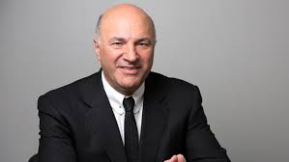

A. List 10 things you learn from this video.

1.

2.

3.

4.

5.

6.

7.

8.

9.

10.

B. Explain, what was the most surprising thing you learned?

C. Explain, how will you use what you learned?

D. Explain, how does this video change how you think about business?

