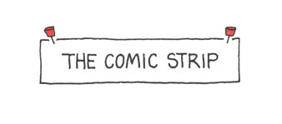
Photoshop / Illustrator Intro to Graphic Design Final Project
Comic Strip Creation:
You can use either Photoshop, Illustrator or both for the final project. Below are some examples of iconic cartoon strips. Your final project is to create your own comic strip. You may not use current characters that already exist in your comic. You must create your own characters.
Your comic strip must include the following items:
- Your initial comic pencil sketches (you will turn these in)
- A title
- A minimum of 25 total boxes
- Original humor (school appropriate)
- Original dialogue using talking bubbles
- Original idea
- Original layout
- Original characters
- A minimum of 3 characters
- A minimum of 5 pages (this would be 5 boxes per page – this is just an example)
- A detailed 1-2 paragraph describing your comic. What is the setting, time frame, character relationships, and any back story to better understand the story.
- Email me your Adobe file. Print all other materials and submit them as a PACKET stapled together.
Have fun and keep it classroom appropriate. I would suggest doing some research before you start. When done, email me your final comic strip. You will also be presenting these to the class. Talking us through your comic strip.
