Canada Trip Budget
You’re planning a trip to Quebec and Ontario in Canada in May and decide to include your vacation budget as part of your personal budget for the six months from January to June. To make the budget as dynamic as possible, you include formulas that reference a Web query that contains a table of currency exchange rate copied from a currency conversion Web site. You can then refresh the worksheet data periodically to see how the latest exchange rates are affecting your six-month budget.

Steps
- Create the worksheet show in the figure below, change the name of the Sheet 1 tab to Budget, then save the workbook as PR C-Canada Trip Budget.
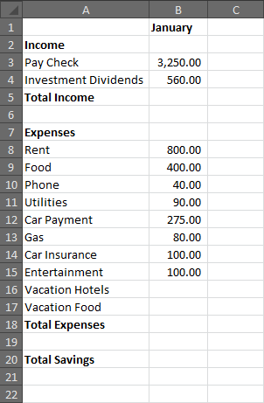

- Use AutoFill to fill in the months from February through June, then center the labels.
- Copy the values for January through June.
- Add a column labeled Totals, then calculate the row total. Verify that all the values are formatted in the Comma Style.
- Calculate the monthly and total income row (row 5), the monthly and total expenses (row 18), and the total savings (row 20). Your total income is $22,860.00, your total expenses are $11,310, and your total savings are $11,5500.
- Click the Data tab, click the From Web button in the Get External Data group, click No if a warning message appears, type the Web site address www.x-rates.com in the Address text box, then click Go. The x-rates.com Currency Conversion Web site opens in the New Web Query dialog box.
- Scroll down the dialog box, then click the table select arrow next to the table shown in the figure shown below. Note that the table select arrow button turns green, and a check mark appears when you click it to indicate that the entire table has been selected.

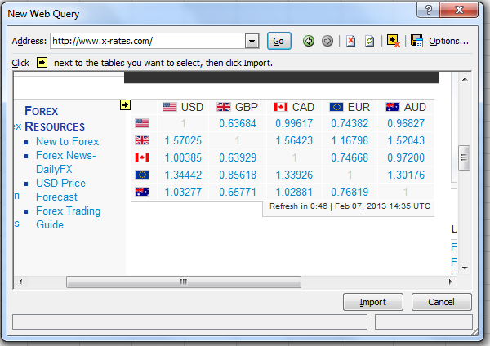

- Click the Import button at the bottom of the dialog box, click the New worksheet option button, then click OK. The formatted data appears in a new worksheet. Note that image files are not included.
- Rename the new worksheet Currency.
- Return to the Budget worksheet, then click cell F16. You will be staying at hotels in Montreal and Toronto for eight days. You’ve checked out hotels on the Internet and decided that 200 Canadian dollars (CAD) per night is a reasonable amount to pay. You’d like to know that this amount converts to in U.S. dollars so you can include the hotel cost in your worksheet. You can also choose to convert the amount to euros or to another currency. However the following steps relate to U.S. dollars.
- In cell F16 of the Budget worksheet, enter the formula =8*200* and leave the insertion point in the cell. Switch to the Currency worksheet, click cell D2 (which contains the exchange rate for Canadian dollars to U.S. dollars), then press [Enter] to add the value from cell D2 to your formula in the Budget worksheet. The value entered in cell F16 represents the cost of hotels for eight days in U.S. dollars, presuming you spend 200 CAD per night.
- Click cell F17, enter the formula =8*100* and leave the insertion point in the cell. Switch to the Currency worksheet, click cell D2, and the press [Enter]. The value in cell F17 represents the cost of food for eight days in U.S. dollars, presuming you spend 100 CAD per day. Note the total savings entered in cell H20.
- Format the worksheet attractively with border lines in the appropriate areas, include Canada Trip Budget and your name in the header, format the worksheet in landscape orientation with the data centered horizontally and vertically, then save the workbook.
- Email the finished workbook to me.

