Name_____________________
Date______________________
Design 1-2nd Hour
DDC Video Questions:
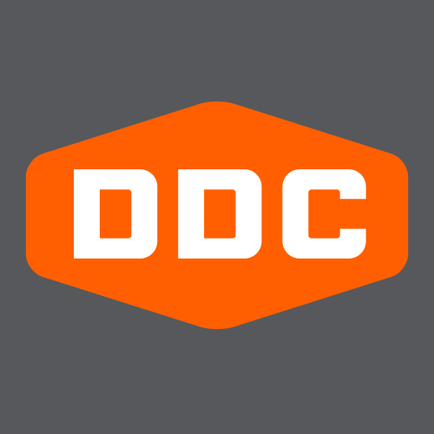

Step 2: While we watch video 1, answer the following interview questions:
- How would Aaron Draplin describe his work and what he does?
- According to Aaron, how does he think his work has evolved through the years?
- What is his take on current design trends?
- What inspires him and keeps him going?
- How important is collaboration in his work process?
- According to Aaron, what would be his best advice to upcoming designers?

Step 3: While we watch video 2, think about, take notes, and answer the questions below:
- What is the name of the company he is creating the Logo for?
- Where is the company from? What state?
- What industry is the company in?
- What does he mean by “show context”?
- What does he mean by “a dark value”?
- What year did he become a freelance designer?
- According to Aaron Draplin, what are the benefits and downfalls of being a freelance designer?
- Lastly, what are your overall thoughts about Aaron Draplin? Are you now, or do you think you will ever be as passionate about design as he is? Explain.

