Kevin O’Leary Video Question
Name______________________________
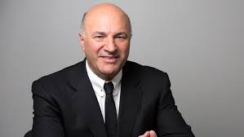

- What does he mean when he says, when running a business, you must be willing to fire your mom?
- How many portfolio companies does he currently have according to the video?
- Why does Kevin carry two phones?
- When does he know, when it time to fire someone?
- What season, did Shark Tank really take off?
- What are the 3 successful attributes he finds in a successful pitch?

- What was the number 1 common attribute, to his business, of the one who are successful and return in capital?
- What is LovePop Cards?
- How does Kevin describe the DNA of business?
- In what state, is this interview taking place?
- Kevin says, “Business is _______!
- When he is thinking about investing, who is the first person he meets with? And why?
- List 5 additional things you learned from this video.

